
Pre-AP Biology
Unit 5 – DNA and Gene Expression
Suggested Duration: 12 Days

DNA and Gene Expression
UNIT PLAN

Table of Contents
UNIT NARRATIVE 1
CONTENT STANDARDS 2
UNDERSTANDINGS AND QUESTIONS 2
ROADMAP 3
UNPACKED STANDARDS 13
VERTICAL ALIGNMENTS…………………………………………………………………………………………………………………………………………………………………………………………....16
VOCABULARY GLOSSARY 17

UNIT NARRATIVE
Students start the unit off with a review of DNA structure, which students started learning in Unit 1. We then move to DNA extraction, with a heavy emphasis on why the household products were able to extract the DNA. Doing this will allow students the opportunity to show mastery of DNA structure (unit 1), chromosomes structure (unit 2), cell membrane structure (unit 1), and biochemistry (unit 1). Students will then move into a Read to Learn about the possible origins of DNA. Students will use their knowledge of DNA structure and DNA replication and apply it to the process of protein synthesis (transcription and translation). They will engage in a case study, hands-on lab, and a Gizmo on protein synthesis where they will have many opportunities to investigate DNA structure and function, RNA structure and function, and how proteins are involved in producing many traits that we see in organisms. Finally, students will investigate what mutations occur and what possible consequences, if any, might be involved. We end the unit with “making connections” and review activities, which will not only allow students to show mastery on Unit 5 content, but also gain appropriate review of all 5 of the units that they will see on the Semester Exam.

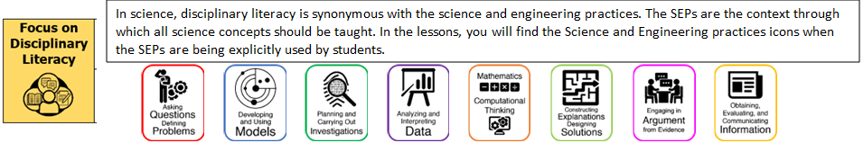

CONTENT STANDARDS
Below are the standards taught and assessed in this unit.
Learning Objectives (Students will be able to…)
B.7.A – Identify components of DNA, explain how the nucleotide sequence specifies some traits of an organism, and examine scientific explanations for the origin of DNA.
B.7.B – Describe the significance of gene expression and explain the process of protein synthesis using models of DNA and ribonucleic acid (RNA).
B.7.C – Identify and illustrate changes in DNA and evaluate the significance of these changes.

UNDERSTANDINGS AND QUESTIONS
Important big ideas and processes for the unit.
Enduring Understandings
- Nucleotides are made up of a phosphate group, a sugar, and a nitrogenous base (adenine, guanine, cytosine, and either thymine or uracil depending on if it is DNA or RNA, respectively.)
- The order in which DNA nucleotides are in dictates which RNA is produced, which dictates the order of amino acids (protein). The proteins used can dictate which trait an organism has.
- A mutation is a change in the DNA sequence.
- A frameshift mutation is when a part of the DNA sequence is removed and the rest just slide down.
- A deletion is a mutation where part of it is removed.
- A substitution is a mutation where one or more nucleotides are substituted for others.
- An insertion is a mutation where nucleotides are added to the DNA sequence.
- Transcription is the process by with DNA is used to make RNA.
- Translation is the process by which RNA is used to produce an amino acid sequence (which will fold up and produce a protein).
Key Questions
- What are the parts of a nucleotide?
- What is the structure of DNA?
- What is the structure of RNA?
- How does a nucleotide sequence specify a trait?
- What are the possible origins of the structure of DNA?
- How is RNA produced during transcription?
- How is protein produced during translation?
- What are the type of mutations and what would their possible consequences be?

ROADMAP
Suggested daily guide for instruction in this unit.

Lesson #1: DNA Structure and Function |  | Date:
Objective  SWBAT: Analyze data to determine nucleotide percentages in the genome of several species of animals.  Standards  B.7.A - Identify components of DNA, explain how the nucleotide sequence specifies some traits of an organism, and examine scientific explanations for the origin of DNA.  Vocabulary  DNA  Adenine  Guanine  Cytosine  Thymine  Hydrogen bond  Science Practices  - Developing and Using Models  - Analyzing and Interpreting Data  - Using Mathematics  - Constructing Explanations  - Engaging in Argument from Evidence  - Communicating Information | Instructional Notes  Part 1: Making Claims About DNA’s Structure  Students work in groups to develop predictions about base ratios in additional example species. They watch a video and revise or confirm their claims accordingly.  Part 2: Modeling DNA structure  Students will collaboratively work with their peers to create a “human” model of DNA. The teacher will lead a discussion while they are in this model stamping ideas such as: arrangement of the molecule, parts of the molecule, the sequence of the molecule determines our “traits” like hair color, skin color, eye color, etc., and where any potential mistakes have been made (A with a G, or C with a T, etc.) – these are called mutations.  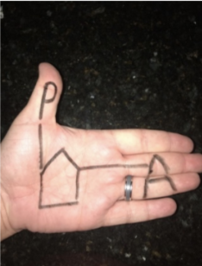 |  | Lesson Look Fors  Look for teachers to:  - Allow students to productively struggle with the content, using accountable talk moves to facilitate the lesson.  - Teachers should be walking around the room ensuring that students are engaged in all activities correctly, consistently monitoring for incorrect biology.  Look for students to:  - Engage in the hands-on-minds-on modeling activity.  - Ask clarifying questions regarding what they are learning.  - Write in complete sentences.  Students Do and Know
   | - Analyze data to determine natural bonding between nitrogenous base pairs.  - Communicate finding to peers.  - Model the structure of DNA using “hand nucleotides.”
   | - Adenine naturally bonds with Thymine in a DNA molecules.  - Cytosine naturally bonds with Guanine in a DNA molecule.  - The three parts of a nucleotide are sugar, phosphate group, and nitrogenous base.

Lesson #2: Digging for DNA |  | Date:
Objective  SWBAT: Model DNA extraction and explain what purpose each household substance had on that extraction.  Standards  B.7.A - Identify components of DNA, explain how the nucleotide sequence specifies some traits of an organism, and examine scientific explanations for the origin of DNA.  Vocabulary  DNA  Adenine  Guanine  Cytosine  Thymine  Hydrogen bond  DNA structure  Plasma membrane  Nucleotides  Histones  Science Practices  - Asking Questions  - Developing and Using Models  - Constructing Explanations  - Engaging in Argument from Evidence | Instructional Notes  ABOUT THIS LESSON  This lesson, Digging for DNA, should be used following a discussion over the basic structure of the DNA molecule. The students will extract DNA  from strawberries and from another substance of their choice. Included in this lesson is an explanation of the basic chemistry behind the extraction, which the students will use to construct a model that will serve as a visual representation of the sequential order for the reagents to proceed to have a successful extraction. The students then use this model to predict possible outcomes of errors made in a hypothetical extraction.  OBJECTIVES  Students will:  - Extract DNA from living cells  - Construct a model of the extraction process and use this model to predict outcomes of hypothetical extraction processes  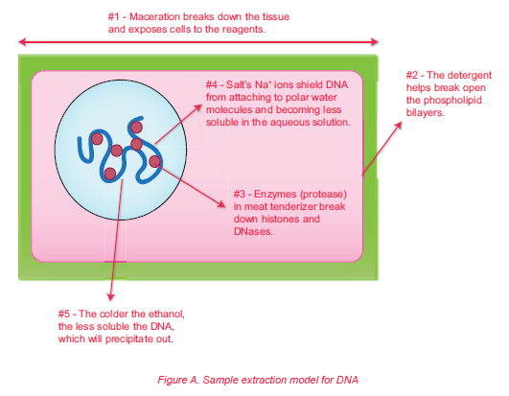 |  | Lesson Look Fors  Look for teachers to:  - Allow students to productively struggle with the content, using accountable talk moves to facilitate the lesson.  - Teachers should be walking around the room ensuring that students are engaged in all activities correctly, consistently monitoring for incorrect biology.  - Ensure that students are accurately using the model to explain why the process and ingredients allows for the extraction of DNA.  Look for students to:  - Engage in the hands-on-minds-on modeling activity.  - Ask clarifying questions regarding what they are learning.  - Write in complete sentences.  - Make connections (interactions) in their own words.  - Be very careful with substances used.  - Work either individually or collaboratively to create a model of a eukaryotic cell (with its constituent parts) and explain how each substance used contributed to the extraction of DNA.  Students Do and Know
  - Follow a DNA extraction procedure.
  - Create a model explaining why substances use worked to extract DNA.
  - DNA is negatively charged.
  - In chromatin, DNA is tightly wound around histone proteins. This allows chromatin and ultimately chromosomes to be as condensed as they are.
  - Plasma membranes are phospholipid bilayers.
Lesson #3: Origin of DNA |  | Date:
Objective  SWBAT: Explain the three main theories about the origin of DNA.  Standards  B.7.A - Identify components of DNA, explain how the nucleotide sequence specifies some traits of an organism, and examine scientific explanations for the origin of DNA.  Vocabulary  DNA  RNA  Nucleotide  Hydrogen bond  Adenine  Guanine  Cytosine  Thymine  Sugar-phosphate backbone  Science Practices  - Developing and Using Models  - Constructing Explanations  - Engaging in Argument from Evidence | Instructional Notes  Have students participate in these practice problems.  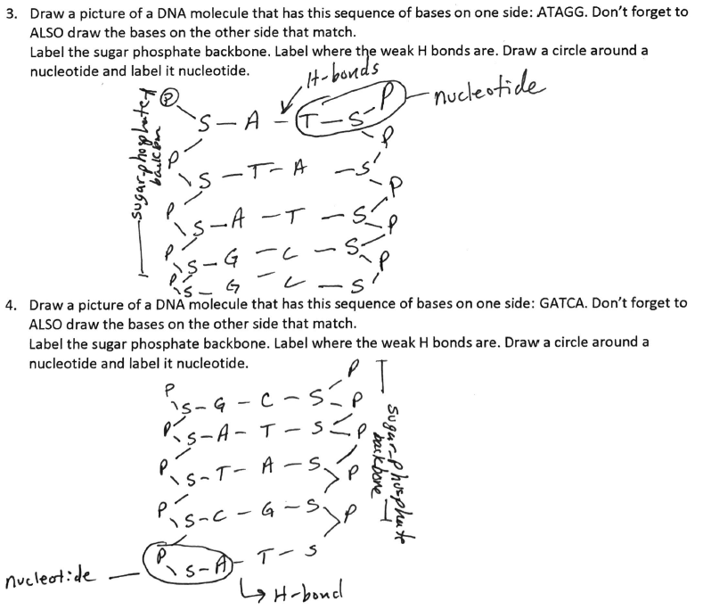  Students will then participate in a Read to Learn about the scientific explanations for the origin of DNA. They answer questions as they go through the Read to Learn. |  | Lesson Look Fors  Look for teachers to:  - Allow students to productively struggle with the content, using accountable talk moves to facilitate the lesson.  - Teachers should be walking around the room ensuring that students are engaged in all activities correctly, consistently monitoring for incorrect biology.  Look for students to:  - Ask clarifying questions regarding what they are learning.  - Write in complete sentences.  - Make connections (interactions) in their own words.  Students Do and Know
  - Create models of DNA.
  - Read an article to discover the scientists involved in the discovery of DNA structure.
  - Adenine naturally bonds with Thymine in a DNA molecules.
  - Cytosine naturally bonds with Guanine in a DNA molecule.
  - The three parts of a nucleotide are sugar, phosphate group, and nitrogenous base.
  - DNA most likely came from RNA in a protein world.

Lesson #4: Protein Synthesis Gizmo |  | Date:
Objective  SWBAT: Explain how genes determine traits through protein synthesis.  Standards  B.7.B – Describe the significance of gene expression and explain the process of protein synthesis using models of DNA and ribonucleic acid (RNA).  Vocabulary  Amino acid  Anticodon  Codon  mRNA  tRNA  nucleotide  DNA  RNA  Ribosome  RNA polymerase  Transcription  translation  Science Practices  - Asking Questions  - Developing and Using Models  - Planning and Carrying Out Investigations  - Using Mathematics  - Constructing Explanations  - Engaging in Argument from Evidence  - Communicating Information | Instructional Notes  Learning Objectives  Students will …  - Identify the differences between DNA and RNA.  - Explain the role of RNA in assembling proteins.  - Describe the processes of RNA transcription and translation.  - Construct a protein molecule by building an amino acid chain.  - Determine which amino acids are specified by different codons.  Lesson Overview  If an organism’s DNA can be thought of as a cookbook containing recipes on how to make and run the organism, than RNA can be thought of as the cook. It is RNA that “reads” DNA’s code and translates it into proteins, the main building blocks of an organism. This process is known as protein synthesis. With the RNA and Protein Synthesis Gizmo, students learn how three different types of RNA—messenger RNA, transfer RNA, and the RNA that makes up ribosomes—work in concert to assemble proteins out of amino acids.  The Student Exploration sheet contains two activities:  - Activity A – Students compare RNA to DNA and build a strand of mRNA.  - Activity B – Students use tRNA to build an amino acid chain, or protein. |  | Lesson Look Fors  Look for teachers to:  - Allow students to productively struggle with the content, using accountable talk moves to facilitate the lesson.  - Teachers should be walking around the room ensuring that students are engaged in all activities correctly, consistently monitoring for incorrect biology.  Look for students to:  - Engage in the hands-on-minds-on modeling activity.  - Ask clarifying questions regarding what they are learning.  - Write in complete sentences.  - Make connections (interactions) in their own words.  Students Do and Know
  - Participate in a Gizmo activity.
  - Compare RNA to DNA and build a strand of mRNA.
  - Use tRNA to build an amino acid chain, or protein
  - DNA is deoxyribonucleic acid.
  - RNA is ribonucleic acid.
  - Transcription is the process of using DNA to produce a strand of RNA.
  - Translation is the process of using RNA to produce a protein.

Lesson #5: Protein Synthesis Modeling |  | Date:
Objective  SWBAT: Investigate how different cells can produce different proteins with the same DNA.  Standards  B.7.B – Describe the significance of gene expression and explain the process of protein synthesis using models of DNA and ribonucleic acid (RNA).  Vocabulary  DNA  RNA  Transcription  Translation  Science Practices  - Developing and Using Models  - Constructing Explanations  - Engaging in Argument from Evidence | Instructional Notes  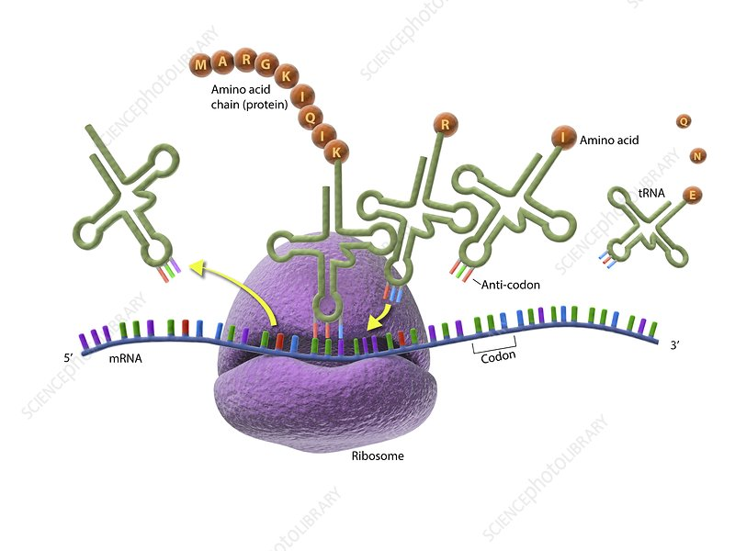  Students will participate in a hands-on-minds-on activity where they work in small groups where they take on the identity of a different cell type. They will use card “amino acids” to build a unique “polypeptide” chain. The idea is for students to understand that different cells build different proteins because they use different genes of the same DNA molecule.  This activity ties in learning from the following TEKS:  - B.7.A  - B.7.B  - B.5.A  - B.6.B |  | Lesson Look Fors  Look for teachers to:  - Allow students to productively struggle with the content, using accountable talk moves to facilitate the lesson.  - Teachers should be walking around the room ensuring that students are engaged in all activities correctly, consistently monitoring for incorrect biology.  Look for students to:  - Engage in the hands-on-minds-on modeling activity.  - Ask clarifying questions regarding what they are learning.  - Write in complete sentences.  - Make connections (interactions) in their own words.  Students Do and Know
  - Use a given code to create an amino acid sequence.
  - Create a model of a protein from a particular specialized cell.
  - Collaborate with others to see the different proteins that were made by all of the different types of cell.
  - DNA is deoxyribonucleic acid.
  - RNA is ribonucleic acid.
  - Transcription is the process of using DNA to produce a strand of RNA.
  - Translation is the process of using RNA to produce a protein.
  - Specialized cells can produce different proteins than other cells by using different genes.

Lesson #6 Sickle Cell Disease |  | Date:
Objective  SWBAT: Investigate the process of protein synthesis to determine the cause of Sickle Cell Anemia.  Standards  B.7B – Describe the significance of gene expression and explain the process of protein synthesis using models of DNA and ribonucleic acid (RNA)  B.7C – Identify and illustrate changes in DNA and evaluate the significance of these changes.  Vocabulary  DNA  RNA  Transcription  Translation  Mutation  Science Practices  - Developing and Using Models  - Constructing Explanations  - Engaging in Argument from Evidence | Instructional Notes  In this inquiry-based activity, students engage in science practices to figure out why some people with a genetic  condition that usually leads to sickle cell disease do not have disease symptoms. This activity is based on content covered in the Scientists at Work video A Genetic Treatment for Sickle Cell Disease. Instead of frontloading information from the film, the activity guides students through “figuring out” the key concepts first. As they investigate and make sense of the phenomenon, students engage in practices such as observing, questioning,  and using and developing models.  This activity is meant to be given to students in separate parts, so that they can focus on figuring out one part before receiving the next and coherently build on their understanding. It is not recommended to provide all parts of the “Student Handout” as a packet together.  - In Part 1, students are introduced to the phenomenon through images and a video clip.  - In Part 2, they observe images of cells and hemoglobin (with and without the sickle cell mutation).  - In Part 3, they sort cards that show steps in the production of hemoglobin (with and without the sickle cell mutation).  - In Part 4, they identify the mutation that causes sickle cell disease by transcribing and translating gene segments.  - In Part 5, they construct models of the protein segments they translated in Part 4.  - In Part 6, they watch the entire video and explore potential treatments with genetic medicine.  - In the optional extension, they transfer what they’ve figured out to Huntington’s disease. |  | Lesson Look Fors  Look for teachers to:  - Allow students to productively struggle with the content, using accountable talk moves to facilitate the lesson.  - Teachers should be walking around the room ensuring that students are engaged in all activities correctly, consistently monitoring for incorrect biology.  Look for students to:  - Engage in the hands-on-minds-on modeling activity.  - Ask clarifying questions regarding what they are learning.  - Write in complete sentences.  - Make connections (interactions) in their own words.  Students Do and Know
  - Sort cards
  - Identify mutations based on evidence
  - Construct models
  - DNA is deoxyribonucleic acid.
  - RNA is ribonucleic acid.
  - Transcription is the process of using DNA to produce a strand of RNA.
  - Translation is the process of using RNA to produce a protein.
  - A mutation is a “mistake” in the DNA sequence.

Lesson #7: Types of Mutations |  | Date:
Objective  SWBAT: Describe how a polypeptide chain might change due to different types of mutations.  Standards  B.7.C – Identify and illustrate changes in DNA and evaluate the significance of these changes.  Vocabulary  Mutation Missense  Frameshift mutation Nonsense  Deletion Silent  Substitution  Insertion  Translocation  Inversion  Duplication  Science Practices  - Developing and Using Models  - Constructing Explanations  - Engaging in Argument from Evidence | Instructional Notes  Activity #1: Teacher will facilitate a PPT on the different types of mutations, which includes lots of examples, models, pictures, and “consequences” of these mutations. Students will fill in guided notes as the teacher goes through the PPT. Alternatively, you could show an Amoeba Sisters Video on mutations.  Activity #2: Students will participate in a card sort activity. They will match up types of mutations with a model of what it looks like, and a real-world example of the consequences it might have (disease, disorder, etc.)  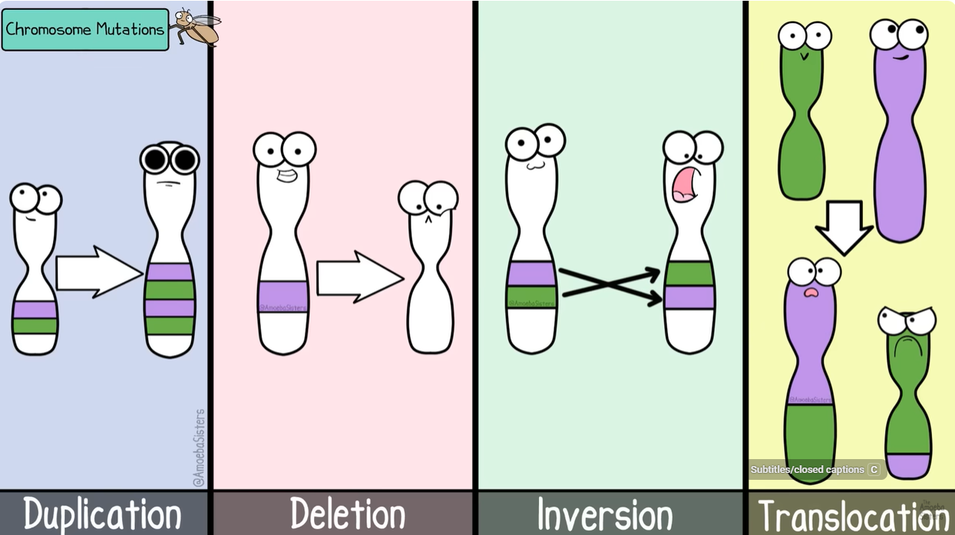 |  | Lesson Look Fors  Look for teachers to:  - Allow students to productively struggle with the content, using accountable talk moves to facilitate the lesson.  - Teachers should be walking around the room ensuring that students are engaged in all activities correctly, consistently monitoring for incorrect biology.  Look for students to:  - Engage in the hands-on-minds-on modeling activity.  - Ask clarifying questions regarding what they are learning.  - Write in complete sentences.  - Make connections (interactions) in their own words.  Students Do and Know
  - Fill out guided notes/thought catcher while teacher is presenting the PowerPoint.
  - Match up types of mutations with their model, consequences, and diseases/disorders.
  - A mutation is a change in the DNA sequence.
  - A frameshift mutation is when a part of the DNA sequence is removed or inserted and the rest slides down.
  - A deletion involves a removal of a part.
  - A substitution is a mutation where one or more nucleotides are substituted for others.
  - An insertion is the addition of nucleotides.
  - A translocation is a mutation where part of a chromosome transports to another place.
  - An inversion is a mutation where a stretch of DNA/chromosomes switches from forward to backward.
  - A duplication is a mutation where part of a DNA sequence is copied causing a frameshift.

Lesson #8: Making Connections |  | Date:
Objective  SWBAT: Explain how different concepts from the DNA and Protein Synthesis unit are related to each other.  Standards  B.7.A - Identify components of DNA, explain how the nucleotide sequence specifies some traits of an organism, and examine scientific explanations for the origin of DNA.  B.7.B – Describe the significance of gene expression and explain the process of protein synthesis using models of DNA and ribonucleic acid (RNA).  B.7.C – Identify and illustrate changes in DNA and evaluate the significance of these changes.  Vocabulary  Mutation  Amino acid  Anticodon  Codon  mRNA  tRNA  nucleotide  DNA  RNA  Ribosome  RNA polymerase  Transcription  translation  Science Practices  - Developing and Using Models  - Engaging in Argument from Evidence | Instructional Notes  Today is all about students practicing making connections among concepts from not only Unit 5 but incorporating their learnings from Units 1-4.  Activity #1: Students are given two sets of cards. The 1st set contains all of the concepts studied in this unit. The 2nd set contains concepts/processes from the past four units. The students will choose one card from the 1st set and one card from the 2nd set and then create a narrative of how these concepts and processes work together to accomplish a common goal.  Activity #2: Students should stay in their groups. Lead a whole group discussion on connections that each group made. Call on a group and ask them to list two concepts and the connection they made between the two. Then, lead a discussion using the following guided questions:  - “Does everyone agree on their connection? Why or why not?”  - “Can anyone make a different connection between those two concepts?”  - “Can anyone add a concept from one of the cards and describe how that concept connects to the two cards (concepts) they chose to share?”  - “Can anyone add a concept from one of the cards and describe how that concept connects to the three cards (concepts) just shared?”  As we prepare students for the SE, this activity is a great way to ensure students not only remember what we’ve taught them in the past, but also how this unit’s content is interrelated to everything that we’ve studied thus far. |  | Lesson Look Fors  Look for teachers to:  - Allow students to productively struggle with the content, using accountable talk moves to facilitate the lesson.  - Teachers should be walking around the room ensuring that students are engaged in all activities correctly, consistently monitoring for incorrect biology.  Look for students to:  - Engage in the hands-on-minds-on modeling activity.  - Ask clarifying questions regarding what they are learning.  - Write in complete sentences.  - Make connections (interactions) in their own words.  Students Do and Know
  - Use connections between and among biological concepts from multiple different units.
  - Use content knowledge to solve real-world scenarios.
  - DNA is deoxyribonucleic acid.
  - RNA is ribonucleic acid.
  - Transcription is the process of using DNA to produce a strand of RNA.
  - Translation is the process of using RNA to produce a protein.
  - Adenine naturally bonds with Thymine in a DNA molecules.
  - Cytosine naturally bonds with Guanine in a DNA molecule.
  - The three parts of a nucleotide are sugar, phosphate group, and nitrogenous base.
  - A mutation is a change in the DNA sequence.

Lesson #9: Review Activity |  | Date:
Objective  SWBAT: Explain the possible origins of DNA and how these nucleotide sequences specify some traits of an organism through the process or protein synthesis.  Standards  B.7.A - Identify components of DNA, explain how the nucleotide sequence specifies some traits of an organism, and examine scientific explanations for the origin of DNA.  B.7.B – Describe the significance of gene expression and explain the process of protein synthesis using models of DNA and ribonucleic acid (RNA).  B.7.C – Identify and illustrate changes in DNA and evaluate the significance of these changes.  Vocabulary  Mutation mRNA  Frameshift mutation tRNA  Deletion nucleotide  Substitution DNA  Insertion Ribosome  Amino acid RNA polymerase  Anticodon Transcription  Codon Translation  RNA  Science Practices  - Asking Questions  - Developing and Using Models  - Planning and Carrying Out Investigations  - Using Mathematics  - Constructing Explanations  - Engaging in Argument from Evidence  - Communicating Information | Instructional Notes  Students will participate in a review activity either individually and/or collaboratively. This review will review all concepts in this unit:  - DNA structure/function  - DNA replication  - RNA synthesis (transcription)  - Protein synthesis (translation)  - Mutations  This activity includes the following types of activities:  - Creating, labeling, and analyzing models  - Multiple choice questions  - Short answer questions  - Matching questions  - A card sort |  | Lesson Look Fors  Look for teachers to:  - Allow students to productively struggle with the content, using accountable talk moves to facilitate the lesson.  - Teachers should be walking around the room ensuring that students are engaged in all activities correctly, consistently monitoring for incorrect biology.  Look for students to:  - Engage in the hands-on-minds-on modeling activity.  - Ask clarifying questions regarding what they are learning.  - Write in complete sentences.  - Make connections (interactions) in their own words.  Students Do and Know
  - Interact collaboratively with peers to complete the review activities.
  - A mutation is a change in the DNA sequence.
  - A frameshift mutation is when a part of the DNA sequence is removed and the rest just slide down.
  - A deletion is a mutation where part of it is removed.
  - A substitution is a mutation where one or more nucleotides are substituted for others.
  - An insertion is a mutation where nucleotides are added to the DNA sequence.
  - DNA is deoxyribonucleic acid.
  - Transcription is the process of using DNA to produce a strand of RNA, and Translation is the process of using RNA to produce a protein.
Day 10 | Flex Day
Day 11 | Review Day
Day 12 | Administer Unit Exam 5

UNPACKED STANDARDS
Focus standards for this unit.

Standards Clarification
Standards | Specificity | Notes/Explanations/Examples
B.7.A – Identify components of DNA, explain how the nucleotide sequence specifies some traits of an organism, and examine scientific explanations for the origin of DNA. | Standard breakdown:  - Identify components of DNA  - Explain how the nucleotide sequence specifies some traits of an organism  - Examine scientific explanations for the origin of DNA  Major concepts in this standard include:  - Components and structure of DNA  - Nucleotide sequence and traits  - The origin of DNA | Instructional Implications  DNA is a nucleic acid made up of nucleotides joined into long strands by covalent bonds. Each nucleotide in DNA is made up of a deoxyribose molecule, a phosphate group, and a nitrogenous base. Understanding the components of DNA and how traits are specified in DNA for an organism by nucleotide base pairs lays the foundation for further genetic study.  When you teach this concept, remember to:  - Use a variety of models and illustrations of DNA, and have students predict the sister strand when provided with one strand.  - Have students create their own DNA models along with written explanations of specific information carried by the DNA molecule.  - Provide opportunities for students to generate base pairs on models or visuals and identify the significance of the hydrogen bonding with base pairs.  - Illustrate that sequences of nitrogenous bases vary widely in DNA and that sequence provides the instructions for the traits of an organism.  Students may make the following mistakes:  - Not connecting the significance of nitrogenous base sequencing with organism traits  - Confusing the base pairings for nucleotides (each has only one)  - Not recognizing the double helix structure of DNA
B.7.B – Describe the significance of gene expression and explain the process of protein synthesis using models of DNA and ribonucleic acid (RNA). | Supports  B.7(C) identify and illustrate changes in DNA and evaluate the significance of these changes  Connection/ Relevance  Most genetic changes occur in DNA and RNA during transcription and translation. | Instructional Implications  Gene expression determines what a particular cell can do, and protein synthesis occurs during transcription and translation. Understanding that gene expression is a regulated process and being able to explain the processes of transcription and translation using models of DNA and RNA is foundational to inheritance, genetics, and evolution.  When you teach this concept, remember to:  - Explore the differences between DNA and RNA.  - Illustrate the base pairs of DNA and RNA.  - Provide opportunities for students to describe and model the process of transcription and translation, including where the processes occur.  - Vary the models, visuals, and codon charts used for transcription and translation.  - Provide opportunities to explore internal and external environmental factors that influence gene expression.  - Identify that most traits are multifactorial traits.  Learning from Mistakes  - Confusing when to use DNA and RNA base pairs  - Thinking that the tRNA strand is used to read a codon chart instead of the mRNA strand  - Thinking that factors such as temperature can regulate genes  - Identifying traits (e.g., coat color) that change due to environmental factors as controlled by DNA mutations rather than gene expression
B.7.C – Identify and illustrate changes in DNA and evaluate significance of these changes. | Standard breakdown:  - Identify changes in DNA  - Illustrate changes in DNA  - Evaluate the significance of changes in DNA  Major concepts in this standard include:  - Gene mutation: point mutation (substitution), insertion, deletion | Instructional Implications  Mutations that cause a change in a single gene are known as gene mutations. Mutations that cause a change in whole chromosomes are called chromosomal mutations. Understanding the type of change that can occur in DNA and how those changes significantly change organisms develops the foundational concepts for the study of evolution.  When you teach this concept, remember to:  - Vary the models and illustrations of DNA, and have students locate varied types of mutations and predict implications to the organism.  - Explore the changes of DNA mutations and evaluate their significance on varied types of codon charts.  - Provide opportunities for students to evaluate mutations in genes/chromosomes and explore the disorders created by these mutations.  - Illustrate that sequences of nitrogenous bases vary widely in DNA and that sequence provides the instructions for the trait of an organism; mutations provide organism variance.  - Show students examples where mutations are helpful for genetic variation.  Students may make the following mistakes:  - Not associating mutations with changes at the chromosomal level in gametes  - Not identifying changes in a new DNA segment that result from a mutation  - Misinterpreting the effects of a mutation on a codon chart  - Not understanding how to transcribe DNA triplets when mutations have occurred  - Confusing the different types of mutation  - Thinking that all mutations are harmful to the organism’s survival

VERTCAL STANDARDS
This section details the progression of key student expectations/standards** in the courses before and after this course. This will help you understand what prior knowledge skills to build upon and guide you in knowing what skills you are preparing your students for in the subsequent course.

Biology Standard | Connections
B.7.A – Identify components of DNA, explain how the nucleotide sequence specifies some traits of an organism, and examine scientific explanations for the origin of DNA. | Kinder: S.K.13.D – Identify ways that young plants resemble the parent plant  1st Grade: S.1.13.C – Compare ways that young animals resemble their parents.  4th Grade: S.4.13.B – Differentiate between inherited and acquired physical traits of organisms.  8th Grade: S.8.13.B – Describe the function of genes within chromosomes in determining inherited traits of offspring
B.7.B – Describe the significance of gene expression and explain the process of protein synthesis using models of DNA and ribonucleic acid (RNA). | Biology: BIO.6.B – Explain the process of cell specialization through cell differentiation, including the role of environmental factors
B.7.C – Identify and illustrate changes in DNA and evaluate significance of these changes. | 7th Grade: S.7.13.D – describe and give examples of how natural and artificial selection change the occurrence of traits in a population over generations.  Biology: B.10.A – analyze and evaluate how natural selection produces change in populations and not in individuals  Biology: B.10.B – analyze and evaluate how the elements of natural selection, including inherited variation, the potential of a population to produce more offspring than can survive, and a finite supply of environmental resources, result in differential reproductive success  Biology: B.10.C – analyze and evaluate how natural selection may lead to speciation

VOCABULARY GLOSSARY
Domain-specific words and definitions for this unit.
Key Content Vocabulary
DNA – a self-replicating material that is present in nearly all living organisms as the main constituent of chromosomes. It is the carrier of genetic information.

RNA – ribonucleic acid, a nucleic acid present in all living cells. Its principal role is to act as a messenger carrying instructions from DNA for controlling the synthesis of proteins, although in some viruses RNA rather than DNA carries the genetic information.

Protein synthesis – Protein synthesis is the process of creating protein molecules. In biological systems, it involves amino acid synthesis, transcription, translation, and post-translational events. ... In translation, the amino acids are linked together in a particular order based on the genetic code.

Translation – In biology, translation is a step in protein biosynthesis where a genetic code from a strand of mRNA is decoded to produce a particular sequence of amino acids.

Transcription – In biology, transcription is the process of transcribing or making a copy of the genetic information stored in a DNA strand into a complementary strand of RNA (messenger RNA or mRNA) with the aid of RNA polymerases.

mRNA – Messenger RNA (mRNA) is a single-stranded RNA molecule that is complementary to one of the DNA strands of a gene. The mRNA is an RNA version of the gene that leaves the cell nucleus and moves to the cytoplasm where proteins are made. During protein synthesis, an organelle called a ribosome moves along the mRNA, reads its base sequence, and uses the genetic code to translate each three-base triplet, or codon, into its corresponding amino acid.

tRNA – Transfer ribonucleic acid (tRNA) is a type of RNA molecule that helps decode a messenger RNA (mRNA) sequence into a protein. ... When a tRNA recognizes and binds to its corresponding codon in the ribosome, the tRNA transfers the appropriate amino acid to the end of the growing amino acid chain.

rRNA – Messenger RNA (mRNA) is a single-stranded RNA molecule that is complementary to one of the DNA strands of a gene. The mRNA is an RNA version of the gene that leaves the cell nucleus and moves to the cytoplasm where proteins are made. During protein synthesis, an organelle called a ribosome moves along the mRNA, reads its base sequence, and uses the genetic code to translate each three-base triplet, or codon, into its corresponding amino acid.

Codon – a sequence of three nucleotides which together form a unit of genetic code in a DNA or RNA molecule.

RNA polymerase – RNA polymerase is an enzyme that is responsible for copying a DNA sequence into an RNA sequence, during the process of transcription.

Mutations – the changing of the structure of a gene, resulting in a variant form that may be transmitted to subsequent generations, caused by the alteration of single base units in DNA, or the deletion, insertion, or rearrangement of larger sections of genes or chromosomes.

Substitution mutation – Substitution is a type of mutation where one base pair is replaced by a different base pair. The term also refers to the replacement of one amino acid in a protein with a different amino acid.

Frameshift mutation – A frameshift mutation is a genetic mutation caused by a deletion or insertion in a DNA sequence that shifts the way the sequence is read. A DNA sequence is a chain of many smaller molecules called nucleotides.

Deletion mutation – Deletion is a type of mutation involving the loss of genetic material. It can be small, involving a single missing DNA base pair, or large, involving a piece of a chromosome.

Duplication – Duplication is a type of mutation that involves the production of one or more copies of a gene or region of a chromosome. Gene and chromosome duplications occur in all organisms, though they are especially prominent among plants. Gene duplication is an important mechanism by which evolution occurs.

Inversion – An inversion occurs when a chromosome breaks in two places; the resulting piece of DNA is reversed and re-inserted into the chromosome. Genetic material may or may not be lost as a result of the chromosome breaks.

Translocation – A translocation occurs when a piece of one chromosome breaks off and attaches to another chromosome. This type of rearrangement is described as balanced if no genetic material is gained or lost in the cell. If there is a gain or loss of genetic material, the translocation is described as unbalanced.

Insertion – A mutation where an extra nucleotide is inserted into the DNA sequence, thus shifting all other behind it down one.

